Incubyte Assessment

Test Report

Name: Manav Nilesh Mehta  
Topic: Library Management System  
  
The below picture shows the results of the test cases which are written in LibraryTest.java file: -  
  
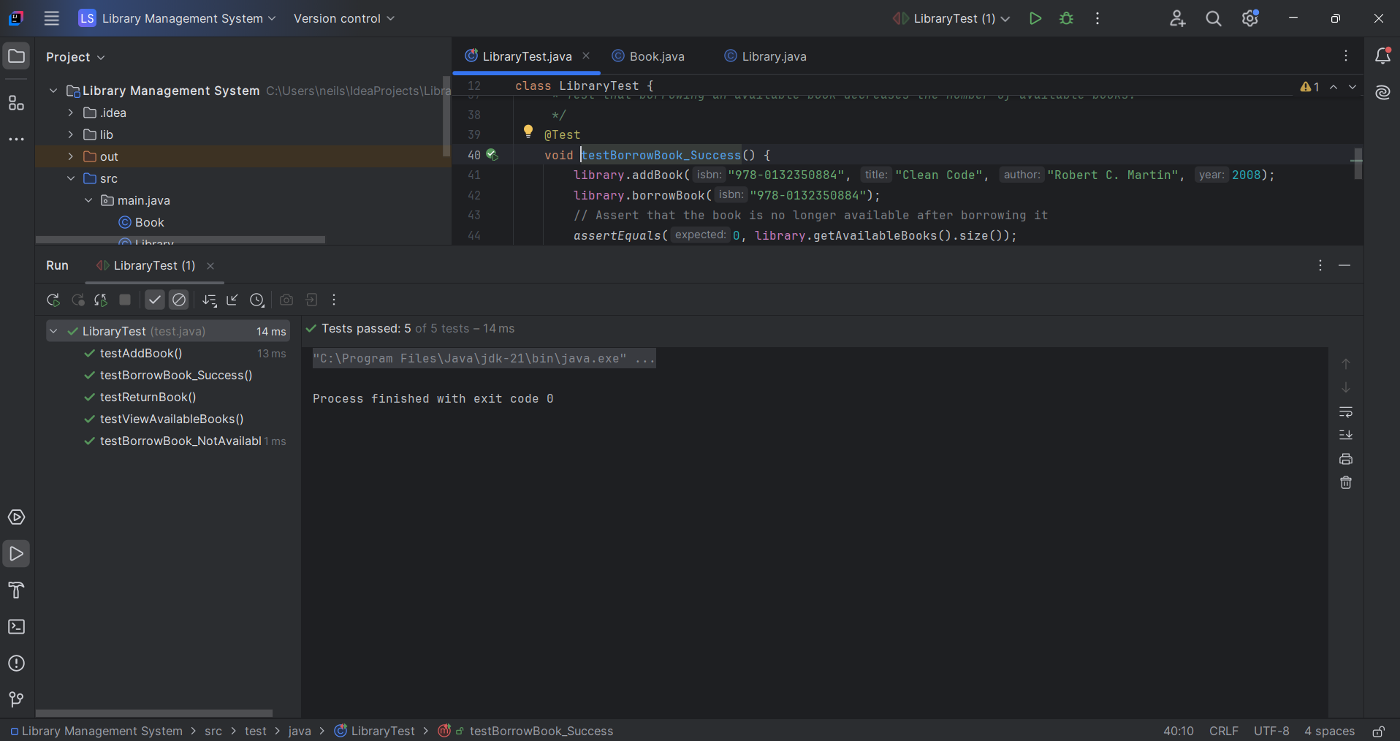  
  
All the test cases have passed.